**Assignment 1:** Create an infographic illustrating the Test-Driven Development (TDD) process. Highlight steps like writing tests before code, benefits such as bug reduction, and how it fosters software reliability.

**Test-Driven Development (TDD)**

**Definition**: TDD is a software development approach where tests are written before writing the actual code.

**TDD Cycle**

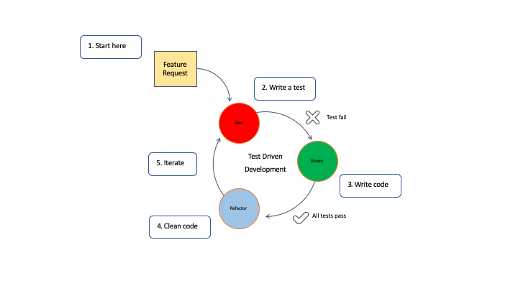

**Write a Test:**

* Define a new functionality or improvement.
* Write a test for this functionality.
* The test will fail initially since the functionality isn't implemented yet.

**Run the Test:**

* Execute the test to see it fail.

**Write Code:**

* Write the minimum amount of code necessary to make the test pass.

**Run Tests Again:**

* Run all tests to see if the new code passes the test.

**Refactor Code:**

* Clean up the code while keeping the test passing.
* Improve code structure and readability without changing its behavior.

**Repeat:**

* Continue the cycle for each new functionality.

**Benefits of TDD**

**Early Bug Detection:**

* Bugs are caught early in the development process.

**Fosters Software Reliability:**

* Ensures that code changes don’t break existing functionality.

**Improves Code Quality:**

* Encourages writing modular and maintainable code.

**Facilitates Refactoring:**

* Makes it safe to refactor code since tests ensure behavior remains consistent.

**Documentation:**

* Tests serve as documentation for code functionality.

#### 

#### **TDD Fosters Software Reliability**

**Consistency**:

* Regular testing maintains consistent behavior.

**Confidence in Code**:

* Developers have more confidence in their code.

**Reduced Debugging Time**:

* Less time spent on debugging and more on development.